AKSA Equipment Inspection Database Administrator’s Guide

Overview 2
Opening the Application 2
Tools 4
Inspections Audit Trail 4
Administration Audit Trail 7
Lookup Tables 9
Sorting records 9
Adding a new record 9
Editing a record 10
Deleting a record 10
Limiting the number of records returned 11
Lookup table form reference 12
Edit Equipment Types 12
Edit Equipment Items 13
Technical Data 14
Relief Valve Technical Data 15
Conservation Vent Technical Data 18
Vessel Technical Data 21
Security 23
User Access 23
Sorting records 24
Adding a new record 25
Editing a record 25
Deleting a record 25
Role Members 26
Adding a new record 26
Editing a record 26
Deleting a record 27

Overview
The AKSA Equipment Inspection Database provides a convenient, web-based interface for entering, editing and printing equipment inspection data sheets and maintaining inspection schedules. This document describes the procedures for administering the application by utilizing the audit trail, updating the lookup tables and maintaining user access.

Opening the Application
A link to the Equipment Inspection Database is located on the AKSA intranet home page under the “Maintenance” header (Figure 1).

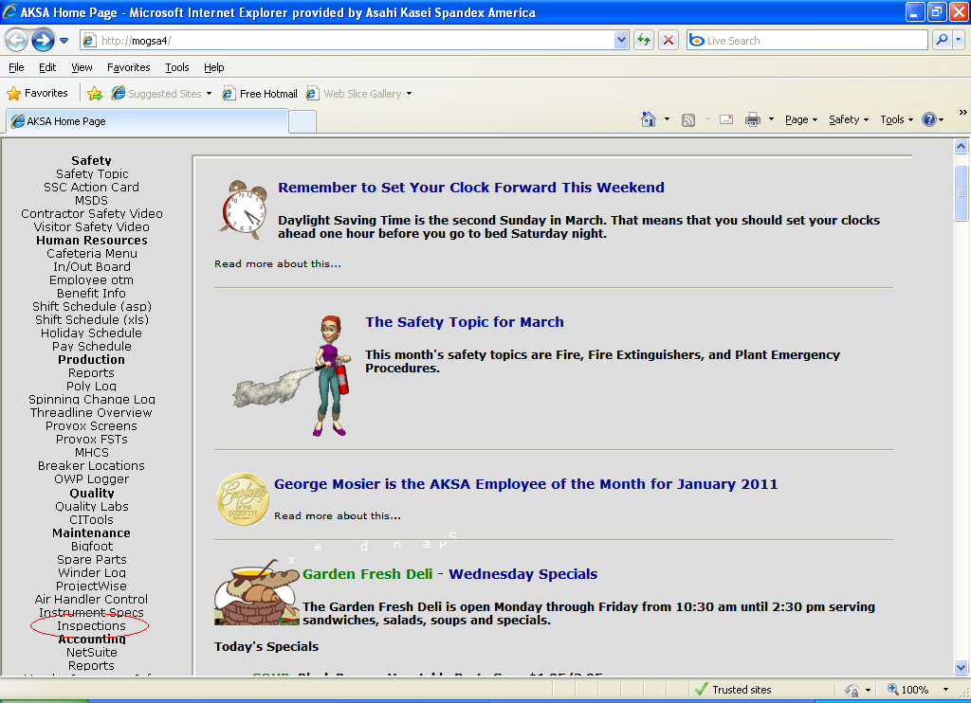
Figure 1

Clicking this link will display the application main menu. The administration main menu is accessed by clicking the “Administration” button (Figure 2).

The Equipment Inspection Database Administration main menu (Figure 3) is divided into three categories for maintaining the application operation:

- Tools – Forms that enable the administrator to query the database in useful ways (e.g. the audit trail).
- Lookup Tables – Forms for updating the base equipment database tables and information used in dropdown lists for data entry.
- Security – Forms for maintaining user access to the application.
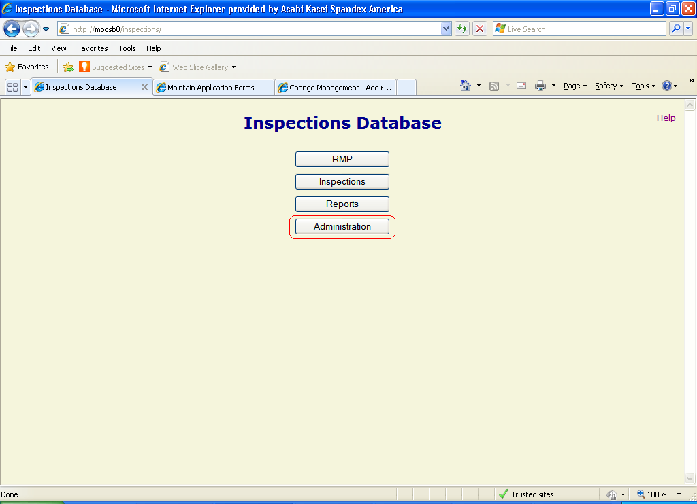
Figure 2

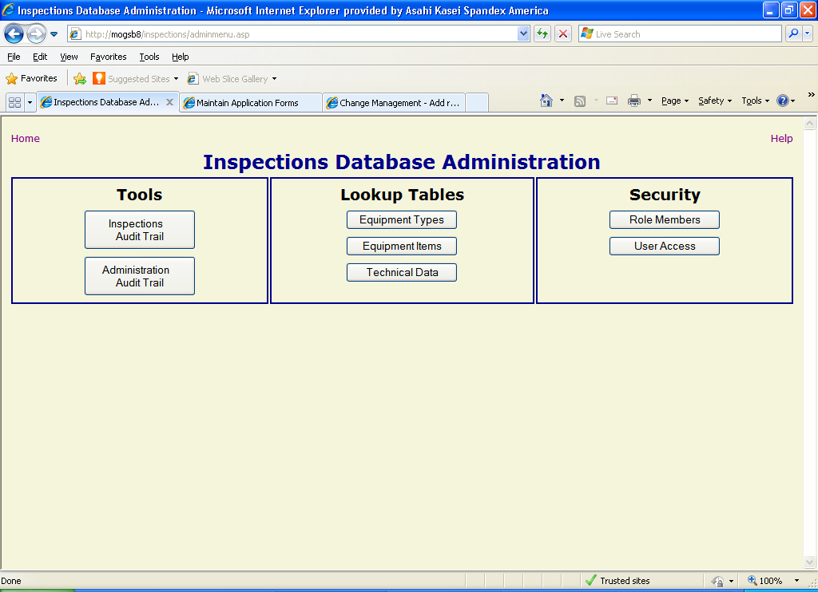
Figure 3

Tools
This category contains useful methods of tracking changes and looking at the data in the Equipment Inspection database.

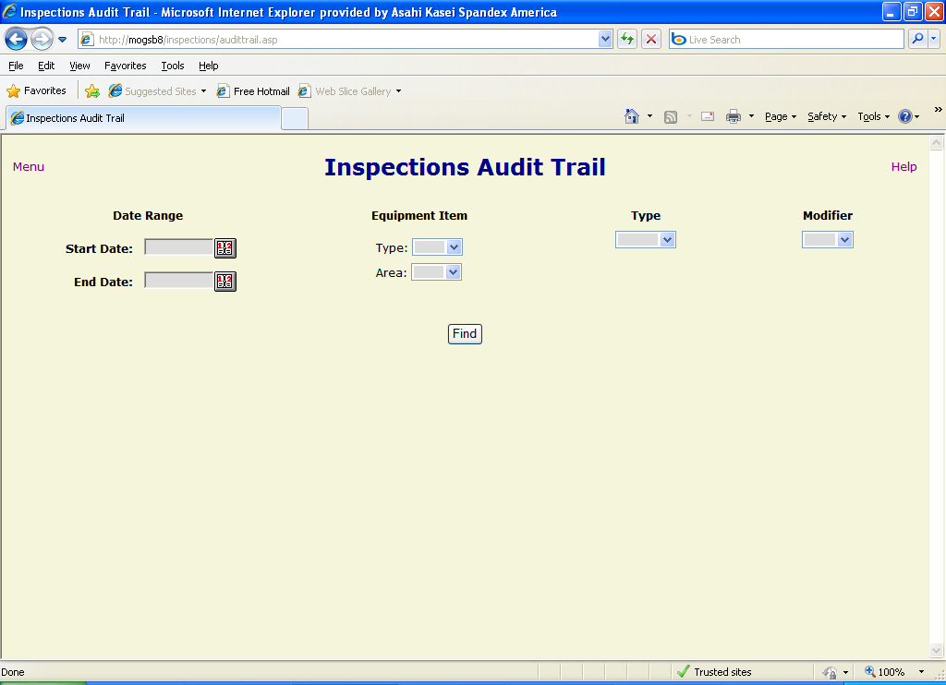
Figure 4

Inspections Audit Trail
The Inspections Audit Trail (Figure 4Error: Reference source not found) is a tool for searching and viewing modifications made to inspection data in the database. The user can select filter criteria to narrow the search results:

- Date Range – A start and end date to limit the time frame in which the change occurred. If the start date is omitted, the search includes the earliest data in the audit trail table up to the end date. If the end date is omitted, the results contain data from the start date to the most recent entry in the table. If both are left blank, then the entire table is searched.
- Equipment Item – The user can specify an individual item for the change. Selecting the desired equipment type (e.g. PSV, Tank, etc.) from the “Type” dropdown list opens a list box of matching item tags (Figure 5), which can be further limited by selecting a specific process area from the “Area” dropdown list.
- Type – The type of change that was made to the data (“delete”, “insert” or “update”). Selecting from this list will limit the results to only the specified type of change.
- Modifier – The username of the individual that made the change. Selecting a user from the dropdown list will limit the results accordingly.

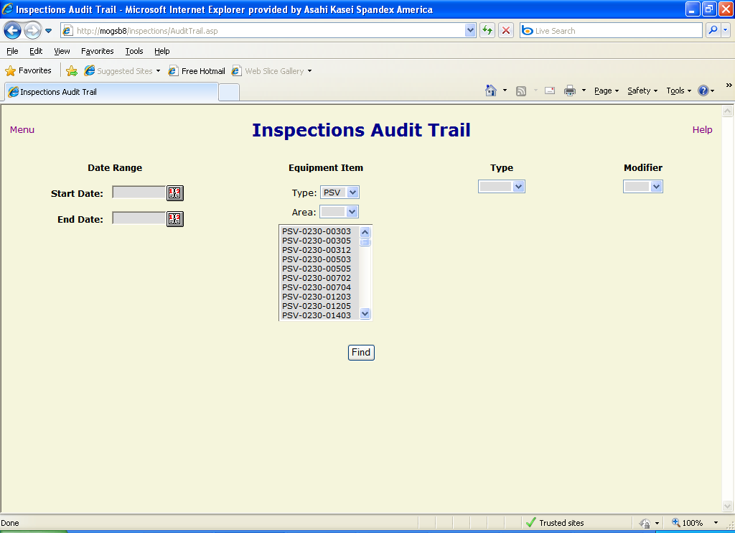
Figure 5

Once the filter criteria have been entered (NOTE: at least one criterion must be chosen), the user clicks on the “Find” button to return the matching results (Figure 6). The records are shown with the following fields:

- Timestamp – The date and time that the modification occurred.
- Modifier – The username of the individual that made the change.
- Instrument – The tag number of the equipment item to whose inspection the change was made.
- Table.Field – The names of the database table and field to which the change occurred. In most cases, the names are descriptive and will readily tell the user what parameter was changed
- Old Value – The value that the field contained before the modification was made.
- New Value – The value to which the field was changed.
- Change Type – The type of data modification (“delete”, “insert” or “update”) that the change involved.

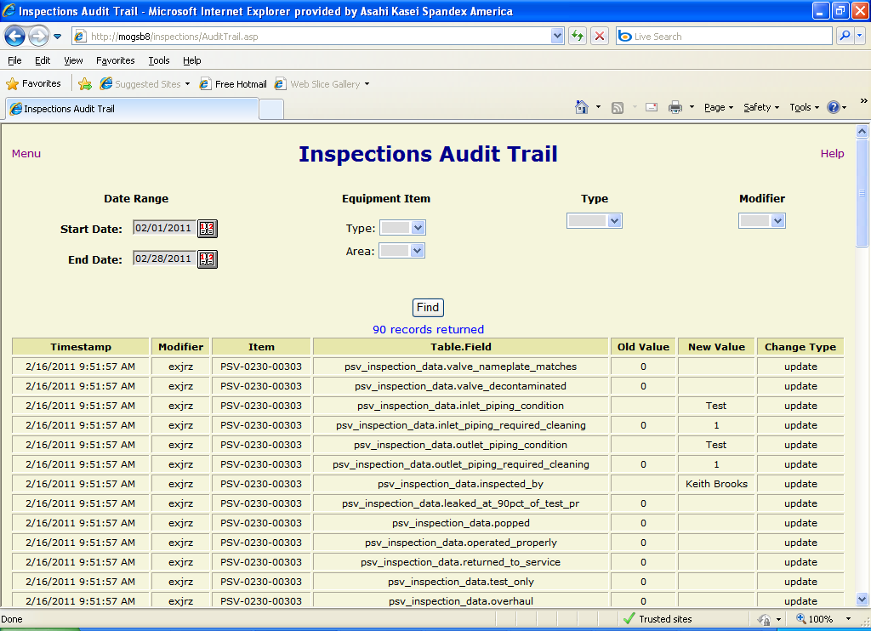
Figure 6

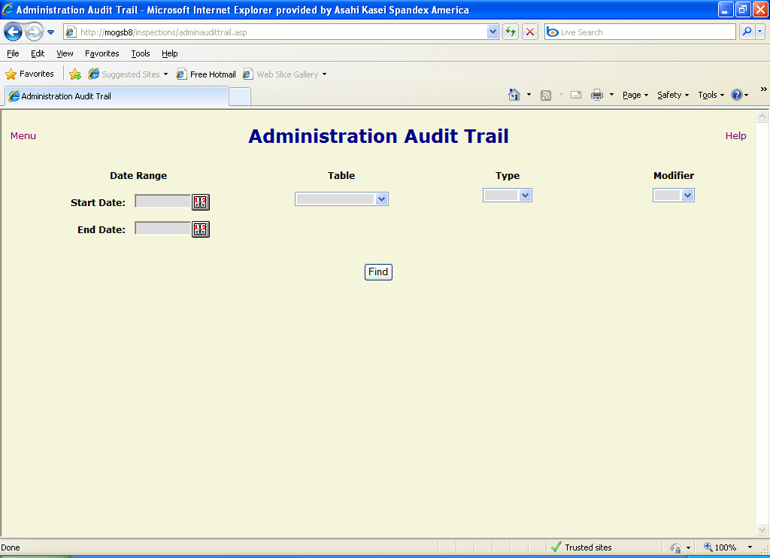
Figure 7

Administration Audit Trail
The Administration Audit Trail (Figure 7) allows users to search and view changes made to the administrative (i.e. “lookup”) and base equipment tables in the database. The user can use the following filter criteria to limit the search results:

- Date Range – A start and end date to limit the time frame in which the change occurred. If the start date is omitted, the search includes the earliest data in the audit trail table up to the end date. If the end date is omitted, the results contain data from the start date to the most recent entry in the table. If both are left blank, then the entire table is searched.
- Table – Data in a relational database is stored in tables. The user can select from a list of administrative tables to specify the type of data being searched for. In most cases, the names of the tables are descriptive of the category of data contained. Choosing a table from the list will only return modifications to data in that particular table. If the table “technical_data” is selected, the user is presented with options that allow him/her to limit the results to changes made to technical data for a specific type of equipment or an individual item. Selecting the desired equipment type (e.g. PSV, Tank, etc.) from the “Type” dropdown list opens a list box of matching item tags (Figure 8), which can be further limited by selecting a specific process area from the “Area” dropdown list.

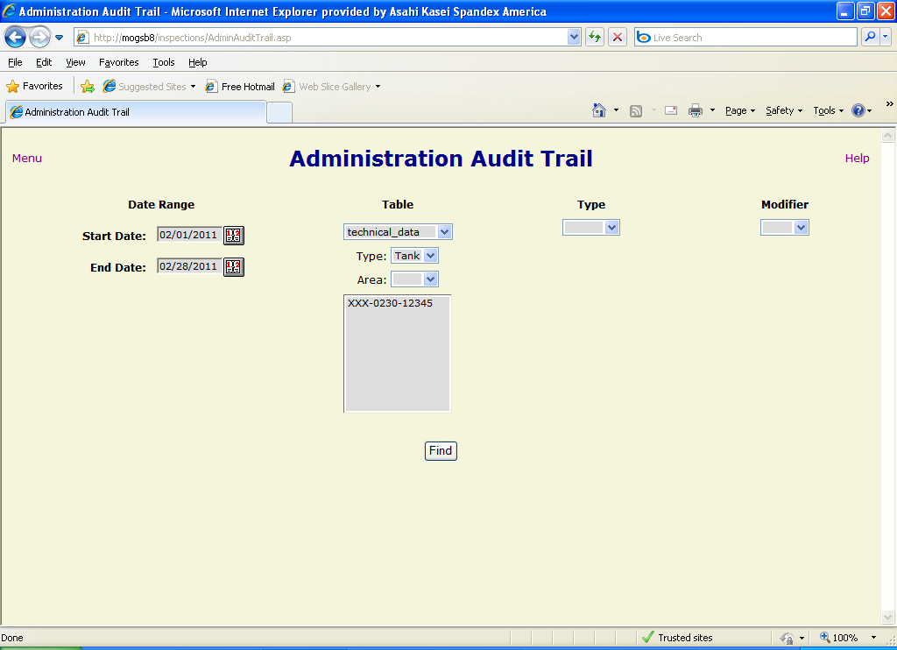
Figure 8

- Type – The type of change that was made to the data (“delete”, “insert” or “update”). Selecting from this list will limit the results to only the specified type of change.
- Modifier – The username of the individual that made the change. Selecting a user from the dropdown list will limit the results accordingly.

Once the user has selected the filter criteria (NOTE: at least one filter must be entered), the user clicks on the “Find” button to return the matching results (Figure 9). The records are shown with the following fields:

- Timestamp – The date and time that the modification occurred.
- Modifier – The username of the individual that made the change.
- Table ID – The primary key (unique identifier) of the record in the table being modified.
- Table.Field – The names of the database table and field to which the change occurred. In most cases, the names are descriptive and will readily tell the user what parameter was changed.
- Old Value – The value that the field contained before the modification was made.
- New Value – The value to which the field was changed.
- Change Type – The type of data modification (“delete”, “insert” or “update”) that the change involved.

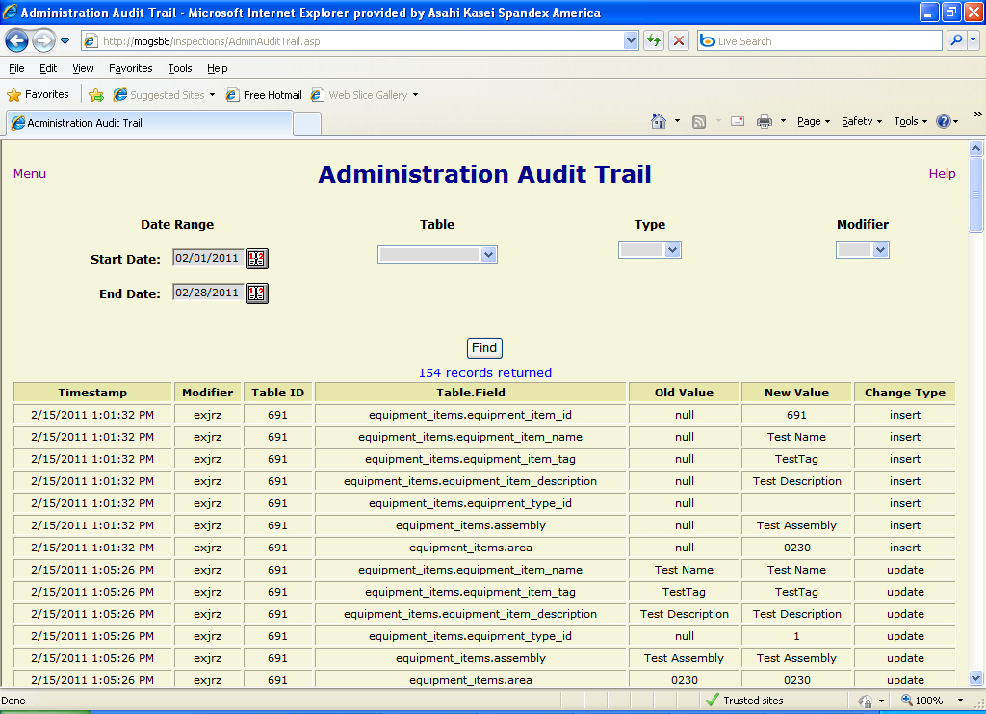
Figure 9

Lookup Tables
The Lookup Tables section provides links to forms that allow an administrator to view and modify the tables that contain the data utilized in dropdown lists on forms, as well as base equipment data. Most of the forms have the same functionality for sorting, inserting, updating and deleting table records, but some have additional options to limit the display of large numbers of records. NOTE: Some of the options described below may not be accessible to a user based on that user’s permissions.

Sorting records
For most forms, each column header for a displayed table has links to allow the user to sort the table records based on the data contained in that column. Clicking on the icon sorts the records in descending order (e.g. 5, 4, 3, 2, 1), while clicking on the icon sorts the records in ascending order (e.g. 1, 2, 3, 4, 5).

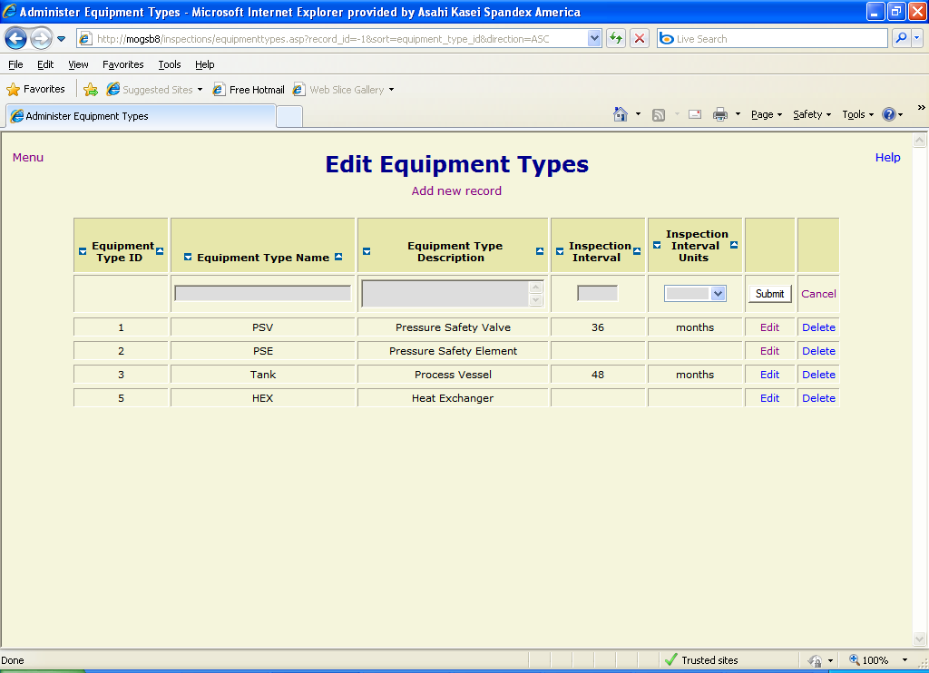
Figure 10

Adding a new record
To insert a new record into the table associated with a lookup table form, click on the “Add new record” link below the page title. A blank record will be opened in the first row of the table with text boxes or dropdown lists displayed for modifiable fields (Figure 10). Enter the desired data in the fields and click the “Submit” button to insert the record. The page will refresh with the new record in its appropriate position based on the specified sort order. To cancel the insertion of a record before submitting, click the “Cancel” link or use your browser’s “back” button.

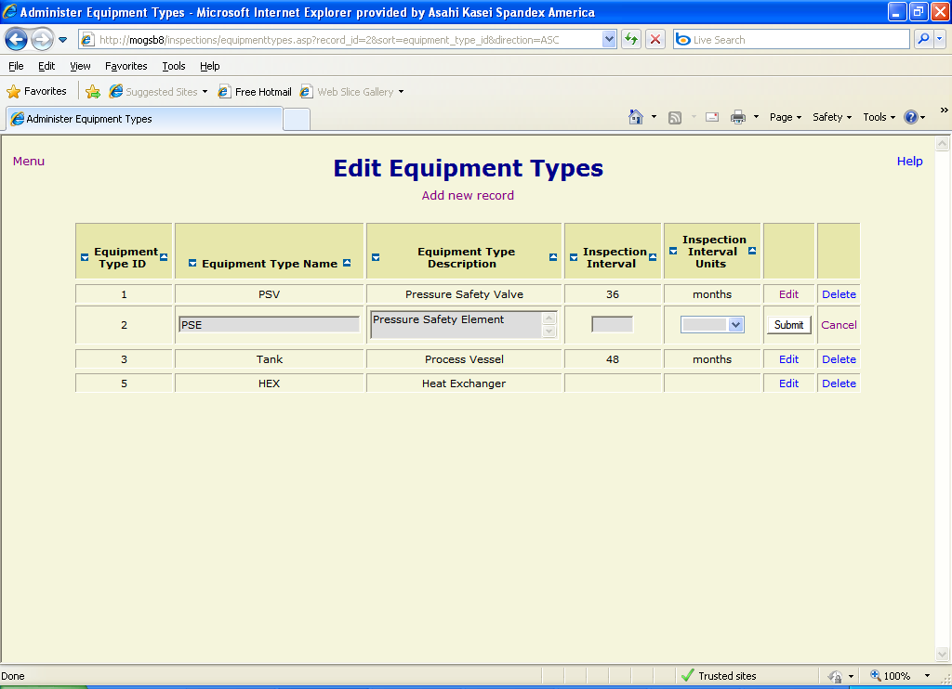
Figure 11

Editing a record
To edit an existing record, click on the “Edit” link to the right of the record to be modified. The record will be displayed with modifiable fields as text boxes or dropdown lists (Figure 11). After changing the field values as desired, click the “Submit” button to the right of the record to update the database. To cancel the update before submitting, click the “Cancel” link or use the “back” button on your browser to return to the previous screen.

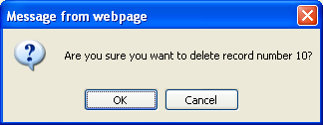
Figure 12

Deleting a record
To delete an existing record, click the “Delete” link to the right of the record to be deleted. A confirmation message (Figure 12) will be displayed. Click the “OK” button to complete the deletion or the “Cancel” button to stop it.

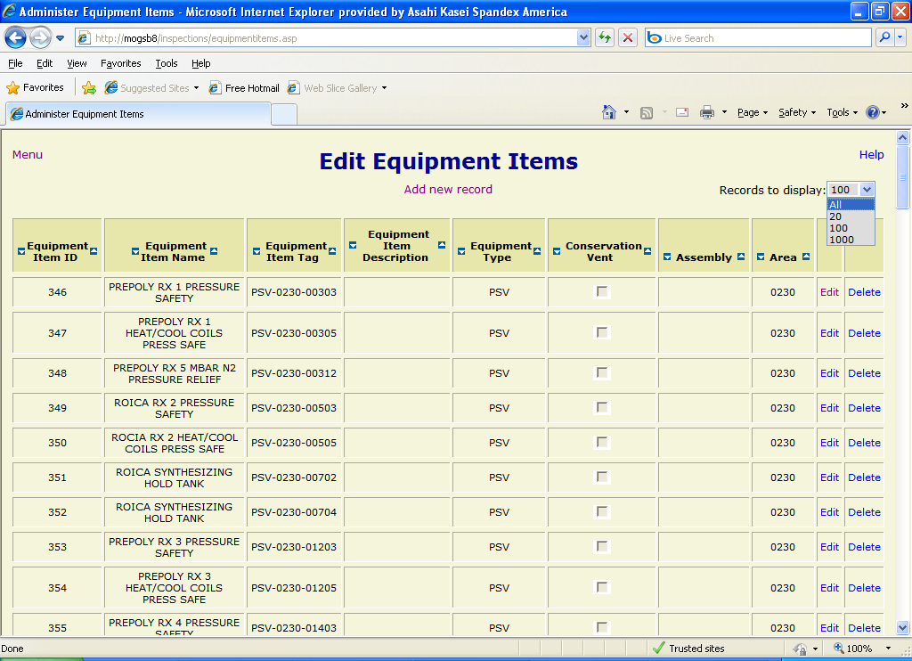
Figure 13

Limiting the number of records returned
Since some of the tables in the Equipment Inspection database contain a large number of records, it is sometimes necessary to limit the number of records returned to improve application performance. Forms for these tables offer such an option. By opening the “Records to display” dropdown list in the upper right-hand corner of the form, the user can select the number of items to return from a list of options (Figure 13). When the user clicks on the desired option, the page is redrawn to display the corresponding number of records. If the number selected is large, the page update may take considerable time.

Lookup table form reference

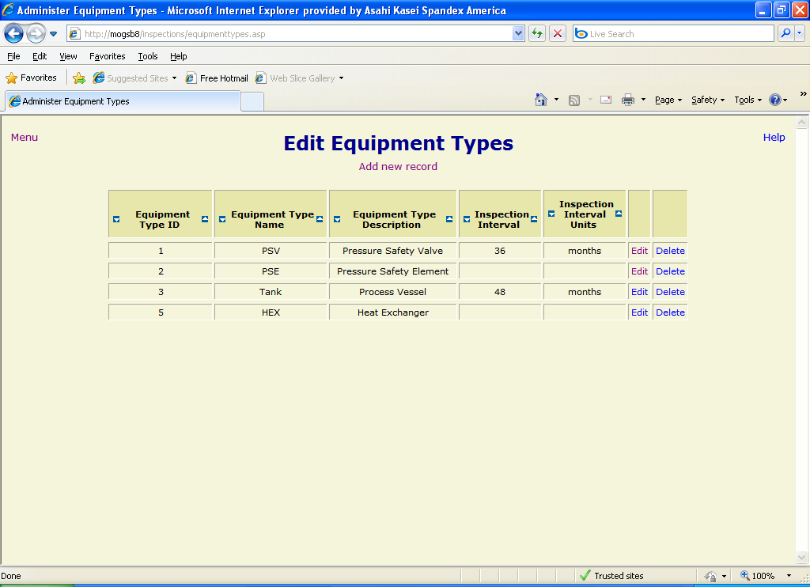
Figure 14

Edit Equipment Types
Updates the equipment_types table. This data is used in the equipment_items table and various query forms. The equipment type is also integral to inspections and technical data in that the corresponding data is different for each equipment type The table consists of the following fields:
- equipment_type_id – Unique identifier, automatically assigned.
- equipment_type_name – Short name of the equipment type (required, must be unique). This field is what is generally displayed in dropdown lists on other forms.
- equipment_type_description – Description of the equipment type (required, must be unique).
- inspection_interval – Default time between inspections for this equipment type.
- inspection_interval_units – Units for inspection interval (“days”, “months” or “years”).

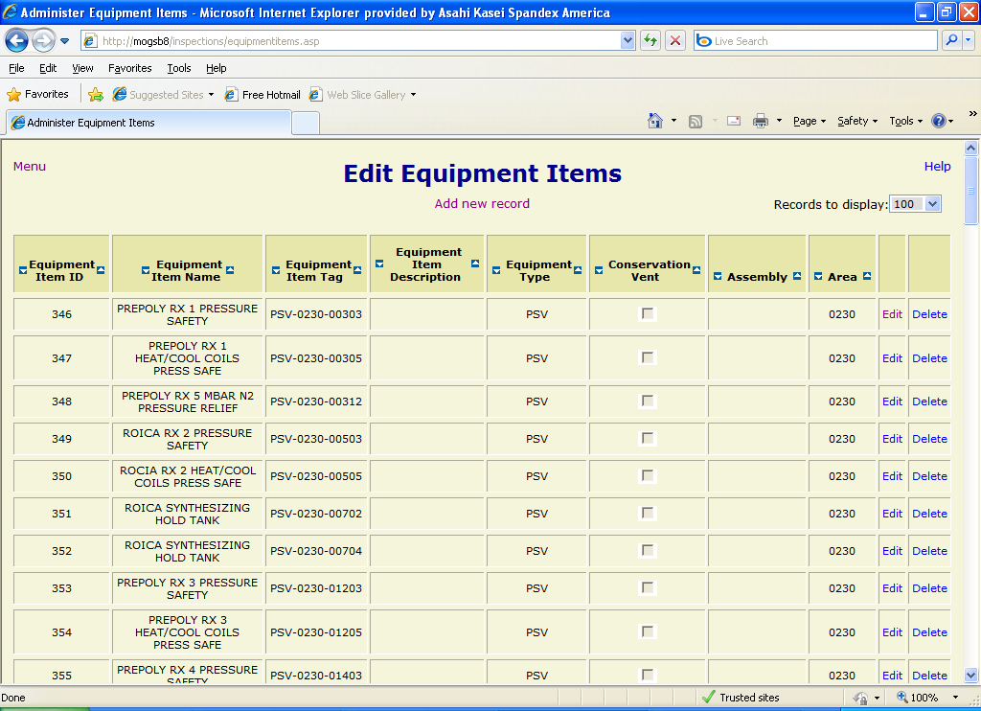
Figure 15

Edit Equipment Items
Updates the equipment_items table. This data is used on inspection and technical data forms, as well as various query forms. The table contains the following fields:
- equipment_item_id – Unique identifier, automatically assigned.
- equipment_item_name – Name of the piece of equipment (required).
- equipment_item_tag – Process tag of the item of equipment (required, must be unique).
- equipment_item_description – Description of the piece of equipment.
- equipment_type_id – Type of equipment, id number from equipment_types table.
- conservation_vent – Indicates if this item is a conservation vent, to allow the appropriate inspection and technical data forms to be displayed.
- assembly – Assembly name for the equipment item.
- area – Process area (e.g. 0230, 0251, etc.) to which the item is assigned.

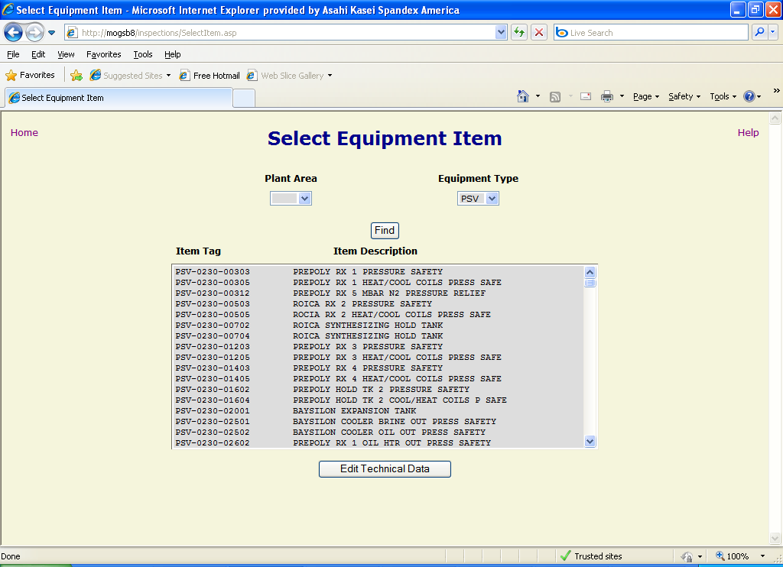
Figure 16

Technical Data
Since the technical data requirements for different types of equipment are, necessarily, different, the technical data for the various equipment types are stored in separate tables in the database with separate forms to modify the data. Clicking on the “Technical Data” button on the administration menu opens the “Select Item” form. The user selects filter criteria from the “Plant Area” and/or “Equipment Type” dropdown lists and clicks the “Find” button to get a list of matching equipment items (Figure 16). Once the user double-clicks an item in the equipment item list or selects an item and clicks the “Edit Technical Data” button, the appropriate form for that item’s equipment type is opened (see below). If the user neglects to select an equipment item before clicking the “Edit Technical Data” button, an error is displayed (Figure 17).

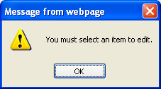
Figure 17

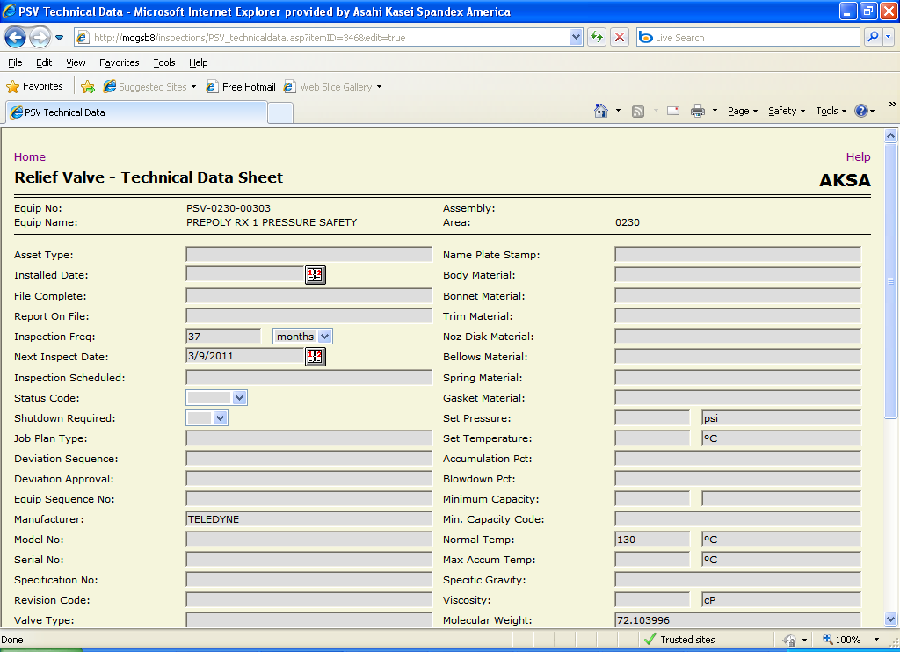
Figure 18

Relief Valve Technical Data
This form allows the user to enter new and update existing data for items of equipment type “PSV” (except conservation vents), which is stored in the psv_technical_data table. It consists of the following fields:
- asset_type – the fixed asset type of the equipment.
- installed_date – the date the item was installed in the process.
- file_complete – the ?
- report_on_file – the ?
- inspection_frequency – the duration between scheduled inspections.
- inspection_frequency_units – the units for the duration between scheduled inspections. Limited to “days”, “months” and “years”.
- next_inspection_date – the date of the next time that the equipment is scheduled to be inspected.
- inspection_scheduled – indicates if the next inspection for the equipment has already been scheduled.
- status_code – the status of the equipment, “ACTIVE” or “SPARE”.
- shutdown_required – whether or not the inspection of this equipment must be performed during a plant shutdown (“YES” or “NO”).
- job_plan_type – the?
- deviation_sequence – the ?
- deviation_approval – the ?
- equip_sequence_no – the ?
- manufacturer – the name of the company that made the equipment item.
- model_number – the manufacturer’s assigned designation for the equipment item.
- serial_number – the manufacturer’s unique identifier for the equipment item.
- specification_number – the unique identifier for the AKSA specification for the item.
- revision_code – the current revision number of the specification.
- valve_type – the type of pressure safety valve (e.g. “Conventional”, “Bellows”, etc.)
- fluid_service – the name of the fluid in the equipment that the valve is associated with (e.g. “DMAC”, “Nitrogen”, etc.).
- fluid_state – the normal state of the fluid in the equipment that the valve is associated with (e.g. “G” (gas) or “L” (liquid)).
- calculated_orifice_size – the calculated size of the valve opening.
- calculated_orifice_size_units – the units for the calculated orifice size (e.g. “in²”).
- selected_orifice_size – the actual size of the valve opening.
- selected_orifice_size_units – the units for the selected orifice size (e.g. “in²”).
- orifice_designation – the industry standard designation letter for the selected orifice size (“D” through “T”).
- in_connect_size – the valve input connection size.
- in_connect_size_units – the units for the input connection size (e.g. “in.”).
- in_connect_type – the type of the valve input connection (e.g. “150# FLG”).
- out_connect_size – the valve output connection size.
- out_connect_size_units – the units for the output connection size (e.g. “in.”).
- out_connect_type – the type of the valve output connection (e.g. “150# FLG”).
- bonnet_type – the type of the valve bonnet (e.g. “CLOSED”).
- cap_type – the type of the valve cap (e.g. “SCREWED”).
- lifting_gear_type – the type of the valve lifting gear (e.g. “PACKED”).
- gag – indicates whether a gag should be used during testing (“YES” or “NO”).
- name_plate_stamp – the ? (e.g. “ASME UV”).
- body_material – the material that the valve body is made of (e.g. “316 STAINLESS”).
- bonnet_material – the material that the valve bonnet is made of (e.g. “CARBON STEEL”).
- trim_material – the material that the valve trim is made of (e.g. “316 STAINLESS”).
- noz_disk_material – the material that the valve nozzle and disk are made of (e.g. “316 STAINLESS”).
- bellows_material – the material that the valve bellows is made of (e.g. “316 STAINLESS”).
- spring_material – the material that the valve spring is made of (e.g. “CHROME ALLOY”).
- gasket_material – the material that the valve gasket is made of (e.g. “IRON”).
- set_pressure – the pressure at which the valve is set to open.
- set_pressure_units – the units for the pressure at which the valve is set to open (e.g. “psi”, “bar”, etc.).
- set_temperature – the temperature ?
- set_temperature_units – the units for the temperature ? (e.g. “C”, “°F”, etc.)
- accumulation_pct – the ?
- blowdown_pct – the ?
- minimum_capacity – the ?
- minimum_capacity_units – the units for ?
- minimum_capacity_code – the ?
- normal_temp – the normal operating temperature for the valve.
- normal_temp_units – the units for the normal operating temperature for the valve.
- max_accum_temp – the ?
- max_accum_temp_units – the units for the?
- specific_gravity – the specific gravity of the fluid in the equipment that the valve is associated with.
- viscosity – the viscosity of the fluid in the equipment that the valve is associated with.
- viscosity_units – the units for the viscosity of the fluid in the equipment that the valve is associated with (e.g. “cP”, “Pa·s”, etc.).
- molecular_weight – the molecular weight of the fluid in the equipment that the valve is associated with.
- compress_factor – the compressibility factor of the fluid in the equipment that the valve is associated with.
- normal_press – the normal operating pressure for the valve.
- normal_press_units – the units for the normal operating pressure for the valve (e.g. “mbar”, “psi”, etc.).
- super_back_press – the ?
- super_back_press_units – the units for the ?
- diff_set_press – the differential pressure at which the valve is set to open.
- diff_set_press_units – the units for the differential pressure at which the valve is set to open (e.g. “PSI”).
- builtup_back_press – the ?
- builtup_back_press_units – the units for the ?
- discharge_to – the location to which the relief valve discharges (e.g. “ATMOSPHERE”, “OTHER”, etc.).
- used_in_combo – indication of whether the valve is used in combination with another device (“YES” or “NO”).
- comb_dev_tag_no – the equipment tag of the combination device.
- comb_dev_mfgr – the manufacturer of the combination device.
- comb_dev_model – the manufacturer’s assigned designation for the combination device.
- comb_dev_size – the size of the combination device.
- derating_factor – the ?
- marking_tag_required – the ?

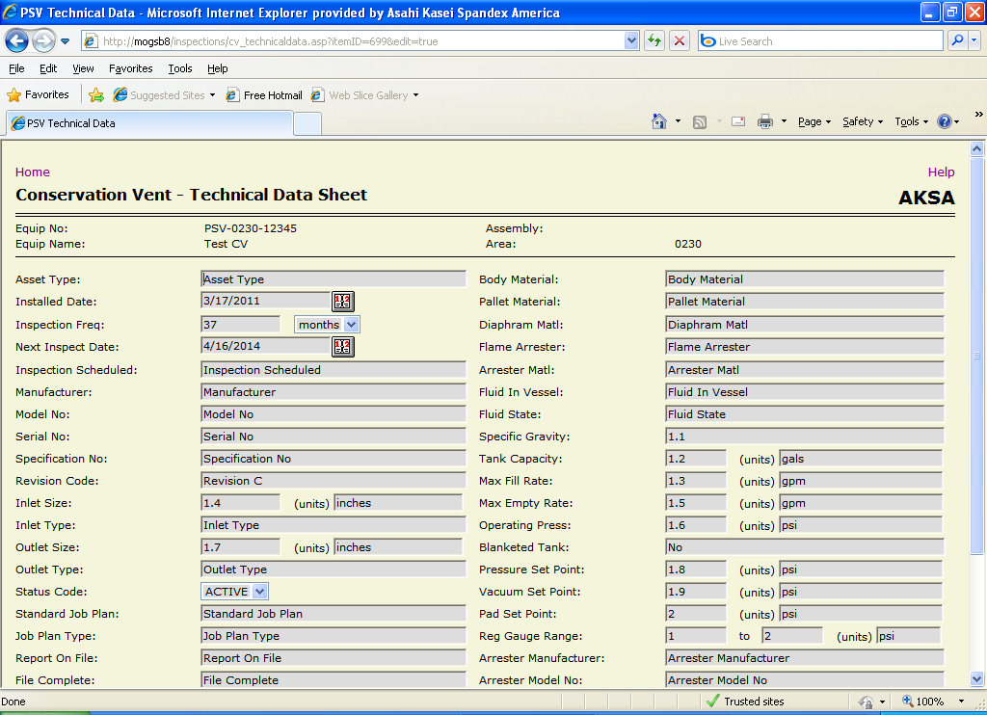
Figure 19

Conservation Vent Technical Data
Equipment items that are of equipment type “PSV”, but have the “Conservation Vent” field checked in the equipment_items table, are automatically directed to this form to allow entry of technical data specific to conservation vents. This form allows the user to enter new and update existing data for this type of item. The data is stored in the psv_technical_data table and consists of the following fields:
- asset_type – the ?
- installed_date – date the item was installed in the process.
- inspection_frequency – the duration between scheduled inspections.
- inspection_frequency_units – the units for the duration between scheduled inspections. Limited to “days”, “months” and “years”.
- next_inspection_date – the date of the next time that the equipment is scheduled to be inspected.
- inspection_scheduled – the ?
- manufacturer – the name of the company that made the equipment item.
- model_number – the manufacturer’s assigned designation for the equipment item.
- serial_number – the manufacturer’s unique identifier for the equipment item.
- specification_number – the unique identifier for the AKSA specification for the item.
- revision_code – the ?
- in_connect_size – the valve input connection size.
- in_connect_size_units – the units for the input connection size (e.g. “in.”).
- in_connect_type – the type of the valve input connection (e.g. “150# FLG”).
- out_connect_size – the valve output connection size.
- out_connect_size_units – the units for the output connection size (e.g. “in.”).
- out_connect_type – the type of the valve output connection (e.g. “150# FLG”).
- status_code – the status of the equipment, “ACTIVE” or “SPARE”.
- standard_job_plan – the ?
- job_plan_type – the?
- report_on_file – the ?
- file_complete – the ?
- deviation_sequence – the ?
- deviation_approval – the ?
- equip_sequence_no – the ?
- body_material – the material that the valve body is made of (e.g. “316 STAINLESS”).
- pallet_material – the material that the pallet is made of (e.g. “Aluminum”).
- diaphram_material – the material that the diaphragm is made of (e.g. “FEP Film”).
- flame_arrester – indicates if the vent utilizes a flame arrester (?)
- arrester_material – the material that the flame arrester is made of (e.g. “Aluminum”).
- fluid_service – the type of material in the associated vessel (e.g. “Nitrogen”).
- fluid_state – the state of the material in the associated vessel (e.g. “Gas”).
- specific_gravity – the specific gravity of the material in the associated vessel.
- tank_capacity – the maximum amount of material in the associated vessel.
- tank_capacity_units – the units for the maximum amount of material in the associated vessel (e.g. “gallons”).
- max_fill_rate – the maximum rate at which the associated vessel can be filled with material.
- max_fill_rate_units – the units for the maximum rate at which the associated vessel can be filled with material (e.g. “gpm”).
- max_empty_rate – the maximum rate at which the associated vessel can be emptied.
- max_empty_rate_units – the units for the maximum rate at which the associated vessel can be emptied (e.g. “gpm”).
- operating_press – the normal pressure at which the vent will operate.
- operating_press_units – the units for the normal pressure at which the vent will operate.
- blanketed_tank – indicates if the associated vessel is blanketed.
- pressure_set_point – for pressure-type vents, the pressure at which the vent begins to lift.
- pressure_set_point_units – for pressure-type vents, the units for the pressure at which the vent begins to lift (e.g. “psi”.
- vacuum_set_point – for vacuum-type vents, the vacuum at which the vent begins to lift.
- vacuum_set_point_units – for vacuum-type vents, the units for the vacuum at which the vent begins to lift (e.g. “psi”).
- pad_set_point – the pressure at which the pad actuates to introduce inert gas.
- pad_set_point_units – the units for the pressure at which the pad actuates to introduce inert gas (e.g. “psi”).
- reg_gauge_range_from – the bottom of the span for the vent regulator gauge.
- reg_gauge_range_to – the top of the span for the vent regulator gauge.
- reg_gauge_range_units – the units for the vent regulator gauge span
- arrester_manufacturer – the name of the company that made the flame arrester.
- arrester_model_number – the manufacturer’s assigned designation for the flame arrester.
- arrester_serial_number – the manufacturer’s unique identifier for the flame arrester.
- arrester_spec_number – the AKSA unique identifier for the specification for the flame arrester.
- code_stamp – the ?

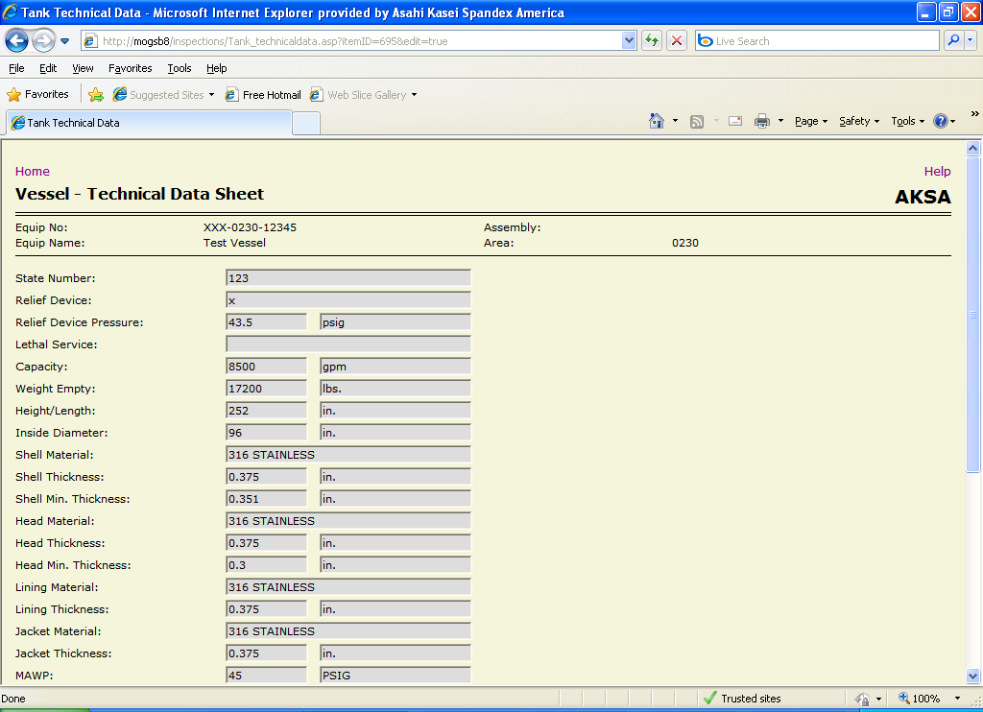
Figure 20

Vessel Technical Data
This form allows the user to enter new and update existing data for items of equipment type “PSV”, which is stored in the psv_technical_data table. It consists of the following fields:
- state_number – the vessel state number.
- relief_device – the equipment tag of the relief device for the vessel.
- relief_device_pressure – the pressure setting for the relief device.
- relief_device_pressure_units – the units for the pressure setting for the relief device (e.g. “psig”).
- lethal_service – indicates whether the vessel will contain a lethal substance (“YES” or “NO”).
- capacity – the maximum volume of the contents of the vessel.
- capacity_units – the units for the maximum volume of the contents of the vessel (e.g. “gallons”).
- weight_empty – the tare weight of the vessel.
- weight_empty_units – the units for the tare weight of the vessel.
- height_length – the height or length of the vessel.
- height_length_units – the units for the height or length of the vessel (e.g. “feet”).
- inside_diameter – the diameter of the interior of the vessel.
- inside_diameter_units – the units for the diameter of the interior of the vessel (e.g. “feet”).
- shell_material – the material that the vessel shell is made of (e.g. “SA 516”).
- shell_thickness – the average thickness of the vessel shell.
- shell_thickness_units – the units for the average thickness of the vessel shell (e.g. “inches”).
- shell_min_thickness – the thickness of the vessel shell at its thinnest point.
- shell_min_thickness_units – the units for the thickness of the vessel shell at its thinnest point (e.g. “inches”).
- head_material – the material that the vessel head is made of.
- head_thickness – the average thickness of the vessel head.
- head_thickness_units – the units for the average thickness of the vessel head.
- head_min_thickness – the thickness of the vessel head at its thinnest point.
- head_min_thickness_units – the units for the thickness of the vessel head at its thinnest point.
- lining_material – the material that the vessel lining is made of.
- lining_thickness – the thickness of the vessel lining.
- lining_thickness_units – the units for the thickness of the vessel lining.
- jacket_material – the material that the vessel jacket is made of.
- jacket_thickness – the thickness of the vessel jacket.
- jacket_thickness_units – the units for the thickness of the vessel jacket.
- mawp – the maximum allowable working pressure of the vessel.
- mawp_units – the units for the maximum allowable working pressure of the vessel.
- shell_test_press – the pressure to be utilized for testing the vessel shell.
- shell_test_press_units – the units for the pressure to be utilized for testing the vessel shell.
- jacket_test_press – the pressure to be utilized for testing the vessel jacket.
- jacket_test_press_units – the units for the pressure to be utilized for testing the vessel jacket.
- date_built – the date that the vessel was manufactured.
- national_board_number – the National Board registration number of the vessel.
- lining_mfgr – the name of the company that manufactured the vessel lining.
- manufacturer – the name of the company that manufactured the vessel.
- mfgr_serial_number – the unique identifier that the manufacturer has assigned to the vessel.
- drawing_number – the unique identifier that AKSA has assigned to the engineering drawing of the vessel.
- jacket_type_description – a description of the vessel jacket type.
- inspection_frequency – the duration between scheduled inspections.
- inspection_frequency_units – the units for the duration between scheduled inspections. Limited to “days”, “months” and “years”.
- next_inspection_date – the date of the next time that the equipment is scheduled to be inspected.
Security
The Equipment Inspection Database application uses integrated authentication and form-level security. This means that users are automatically identified by the system based on their operating system logon and their permissions are examined for each web page that they attempt to access.

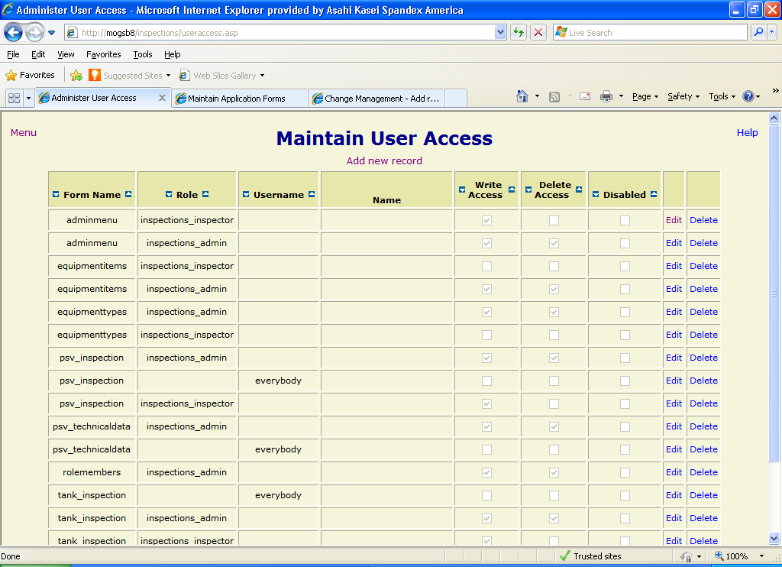
Figure 21

User Access
The “Maintain User Access” form (Figure 21) allows users with the appropriate permission level to assign user or role privileges for each web form. These privileges dictate if a user or role can view a particular form and, if so, the way that it is displayed. The following list describes the rules governing permissions on a given form:
- If no records have been entered for the form, all users and roles have all privileges.
- If a record for the user “everybody” has been entered for the form, all users and roles have the privilege level specified in that record as a minimum.
- If there is at least one record for the form and there is no record for the user ”everybody” and there is no record for a specific user or a role that the user is a member of, that user has no privilege on the form and he will receive a denial message (Figure 22) if he/she tries to access the form.
- If a user has a record entered for the form, his/her privileges on the form are based on the following columns:
  - Write Access – a check mark in this column allows the user to edit and add records in the form. This is accomplished by displaying editable controls and a “Submit” button on inspection and technical data forms or showing the “Edit” and “Add new record” links in administrative forms.
  - Delete Access – a check mark in this column provides the user with the capabilities of “write” access and, in addition, allows him/her to delete records from administrative forms. This is accomplished by displaying the “Delete” link in the form.
  - Disabled – a check mark in this column indicates that the user has no access on the form, regardless of the values in the other columns.
  - If none of the columns are checked, the user has read-only privilege on the form and editable controls, the “Submit” button, and the “Edit”, “Delete” and “Add new record” links will not be displayed.
- If a role has a record entered for a given form, all members of that role (see Role Members below) have the privileges assigned to the role as described above.

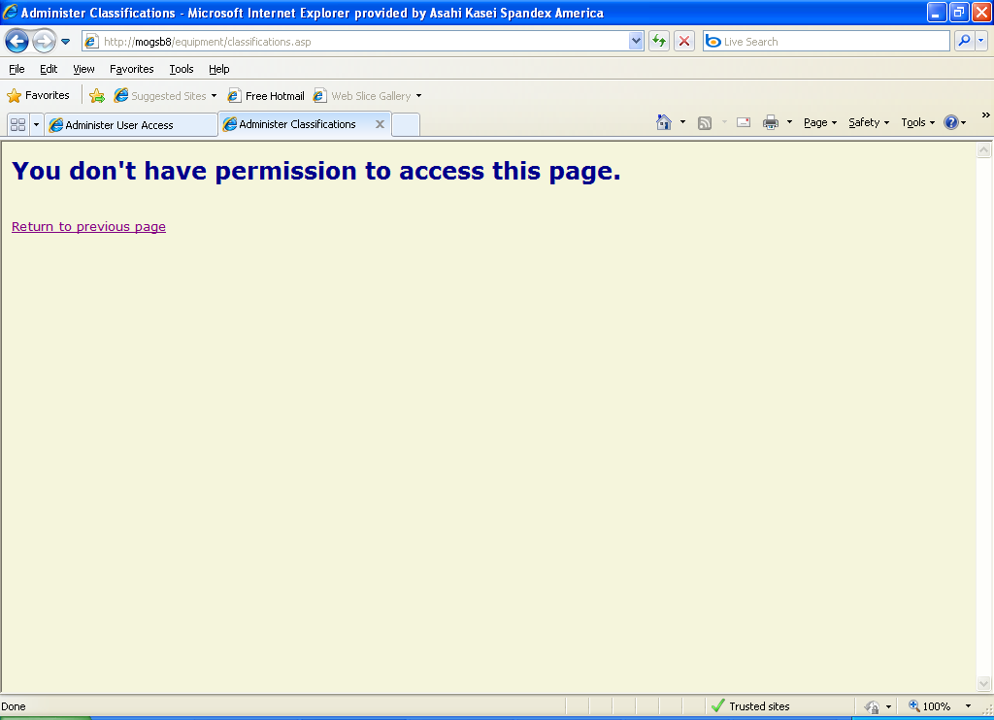
Figure 22

Sorting records
Each column header on the “Maintain User Access” form has links to allow the user to sort the table records based on the data contained in that column. Clicking on the icon sorts the records in descending order (e.g. 5, 4, 3, 2, 1), while clicking on the icon sorts the records in ascending order (e.g. 1, 2, 3, 4, 5).

Adding a new record
To insert a new record into the “Maintain User Access” form, click on the “Add new record” link below the page title. A blank record will be opened in the first row of the table with dropdown lists or checkboxes displayed for modifiable fields. Enter the desired data in the fields and click the “Submit” button to insert the record. The page will refresh with the new record in its appropriate position based on the specified sort order. To cancel the insertion of a record before submitting, click the “Cancel” link or use your browser’s “back” button.

Editing a record
To edit an existing record, click on the “Edit” link to the right of the record to be modified. The record will be displayed with modifiable fields as dropdown lists or check boxes. After changing the field values as desired, click the “Submit” button to the right of the record to update the database. To cancel the update before submitting, use the “back” button on your browser to return to the previous screen.

Deleting a record
To delete an existing record, click the “Delete” link to the right of the record to be deleted. A confirmation message (Figure 23) will be displayed. Click the “OK” button to complete the deletion or the “Cancel” button to stop it.

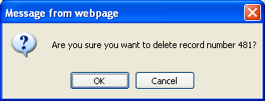
Figure 23

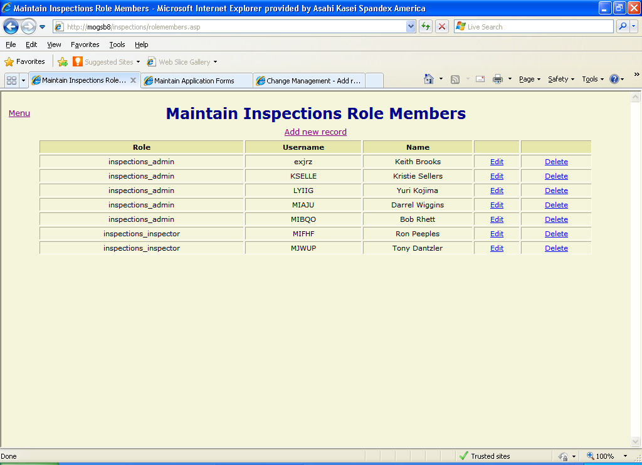
Figure 24

Role Members
The “Maintain Inspections Role Members” form (Figure 24) allows users with the appropriate permission level to assign users to Inspections security roles. The roles are assigned privileges for each form on the “Maintain User Access” form (see User Access above) and a member of a given role inherits that role’s permissions.

Adding a new record
To insert a new record into the “Maintain Inspections Role Members” form, click on the “Add new record” link below the page title. A blank record will be opened in the first row of the table with dropdown lists displayed for modifiable fields. Enter the desired data in the fields and click the “Submit” button to insert the record. The page will refresh with the new record in its appropriate position based on the specified sort order. To cancel the insertion of a record before submitting, click the “Cancel” link or use your browser’s “back” button.

Editing a record
To edit an existing record, click on the “Edit” link to the right of the record to be modified. The record will be displayed with modifiable fields as dropdown lists. After changing the field values as desired, click the “Submit” button to the right of the record to update the database. To cancel the update before submitting, use the “back” button on your browser to return to the previous screen.

Deleting a record
To delete an existing record, click the “Delete” link to the right of the record to be deleted. A confirmation message will be displayed. Click the “OK” button to complete the deletion or the “Cancel” button to stop it.

